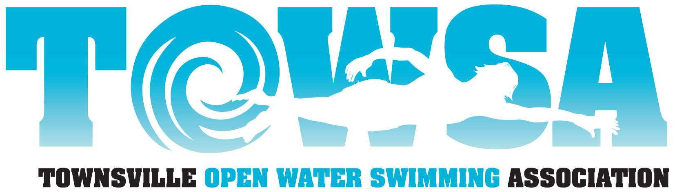 | Townsville Open Water Swim Association Inc  PO Box 1315  Aitkenvale QLD 4814

Magnetic Island to Townsville Swim 2021 Refund Policy

General:
All applications for refund must be made by 1 July. An administration fee of $30 per entry will be retained. As a general rule there will be no refunds after this date, however, a COVID lockdown refund policy is set out below. Should the race be abandoned due to dangerous conditions, no refunds will be made.

Entries affected by CO-VID restrictions:
TOWSA is a small not-for profit association and therefore the ability to provide refunds is affected by the timing of any decision to proceed with the race. Administrative costs of $30 will apply in all cases.
If the decision to cancel the race, or withdraw, due to co-vid restrictions applying to all or a specific entry, is made before merchandise (cap, shirt, towel, etc) is organised then it will be possible to reimburse $50 from paddler amount, $60 from merchandise and $20 from water safety and other costs - a total reimbursement of $130 for solo swimmers, $210 for duos and $370 for teams of four. Alternatively, entries may be carried over to 2022 with no administrative fee applied.

If the decision to cancel the race, or withdraw, due to co-vid restrictions applying to all or a specific entry, is made after merchandise is ordered then it will be possible to refund $50 from the paddler amount and $20 from water safety – a total reimbursement of $70 for solo swimmers, $90 for duos and $130 for teams of four, with merchandise to be provided.

Decisions on refunds will be made in close consultation with those affected.

